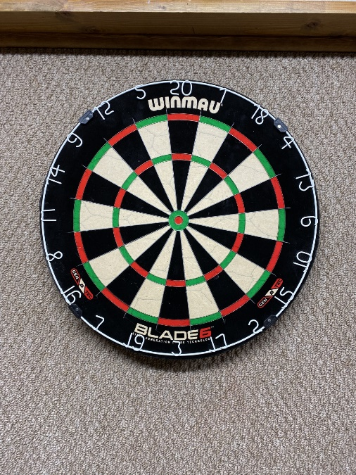**Come check out our new Blade 6 dart boards.**

Drop in darts as follows:

**Monday’s at 12:30 pm** with toe the line at 1pm.

**Thursday’s at 5pm** with toe the line at 5:30 pm.